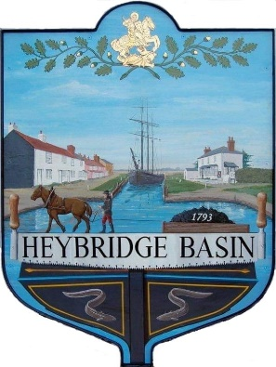
HEYBRIDGE BASIN PARISH COUNCIL
Memorial Post Policy

Introduction

Heybridge Basin Parish Council recognises that members of the community might wish to remember loved ones with a memorial placed within the village. The Council has a Turning Post located within the village and which is intended to serve as a memorial.
It is not intended as a memorial to those who live outside the village except in special circumstances.
It is the intention of the Parish Council that this policy only covers broad common issues and is not meant to be exhaustive. The content of this policy may be revised as necessary at the discretion of the Parish Council to meet changing circumstances.
Criteria for application
- The individual must have resided or worked in the village for at least 10 years.
OR
- Been awarded Honoury Freeman of the Parish Council.
The Plaque
The plaques shall be of a uniform size and colour with a standard typeface.
The total cost of a memorial plaque and its installation will be dependent on the inscription and be paid by the applicant. The cost includes the cost of the plaque, engraving and fixing to the Turning Post. The total cost will be given on receipt of the application.
In order to maintain consistency of appearance and quality, all plaques will be ordered and installed by the Parish Council.

Application
- All applications for a memorial plaque should made on the official application form and signed by the applicant.
- Applicants must include the wording they wish to be on the plaque as part of their application.
- All details including the inscription on any plaque are to be included to enable the Council to consider the full detail. The Council will check that the memorial is appropriate for the community and the environment and that it meets the requirements set out within this policy.
- All applications must be sent directly to the Clerk.
- The application will be considered at the next full Parish Council meeting.
- The Clerk will write to the applicant with the decision, within two weeks of the meeting.
- All successful applicants will be asked to sign and date a copy of this policy.
- In the case of the Council refusing an application there is no appeal process.
Terms and conditions
- All purchase and fitting costs are to be paid for by the applicant in advance of the purchase order being placed.
- No additional mementos such as flowers, statues or vases will be permitted within the vicinity of the Turning Post.
- The Parish Council reserves the right to remove any such mementos or flowers.
- The Council prefers memorials to individuals and will not consider memorials to pets.
- The Council will not grant applications for memorials to, or to scatter the ashes of pets. The scattering of human ashes will also not be permitted
- The Parish Council reserves the right to remove or re-site a memorial plaque ten years from installation or sooner if the plaque is in a poor state of repair.
- The Parish Council’s standards of maintenance will be accepted as keeping the turning post fit for purpose and clean. This will involve occasionally removing algae and grime and repairing minor faults within the resources available.
- The Parish Council is not responsible for the maintenance of memorial plaques.
- The Council accepts no responsibility if a memorial or plaque is damaged, vandalised or stolen and all costs associated with the repair or replacement will be the responsibility of the applicant. In the event that the applicant cannot be contacted by the Council within 56 days of such an occurrence the memorial will be removed, and the site made available to an applicant on the waiting list.
- Memorial plaques may only be removed by the Parish Council.
- Applicants who wish a memorial to be removed must request this from the Council so that the memorial is removed safely. The Council reserves the right to charge for this service.
- The Parish Council reserves the right to re-site or remove memorials at any time however applicants will be notified of the reason why such action was taken as soon as possible.
- All plaques removed from a memorial when the memorial is removed will be stored securely by the Council, unless the applicant wishes to keep.

Review and approved: | Minute:
15th October 2024 | 24/102 b
20th May 2025 | 25/015 a

